Software Development Unit 33, 3.1

Anna Legaspi

# I can assess the effectiveness of different project management techniques

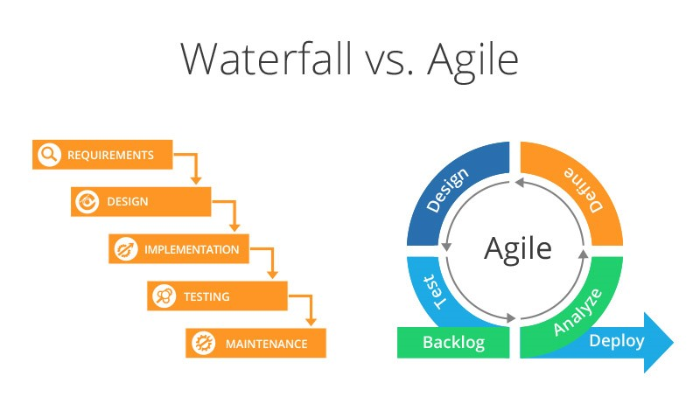

|  |  |
| --- | --- |
| **Effectiveness Comparison** | |
| **Waterfall** | **Agile** |
| It is effective when the requirements are confirmed and finalised in the planning stages. This is useful when there are mandatory and regulatory rules that needs to be followed as it is confirmed and considered from the onset. | It is effective when requirements are not yet completely finalised and the project is open to receiving ongoing feedback from the product owner. There is a not too many restrictive rules for the creativity of the software. |
| It is effective if there is a lot of time to dedicate to the project as Waterfall takes longer to complete, but normally has a definite deadline that produces a final product. | It is effective if the product owner wants to see a basic working product in a shorter time and improvements are made until the final product is complete. However, the deadline of the project is unknown. |
| Is effective when the project has a set, inflexible budget as the cost is planned from the onset. | Is effective if the project has a budget, but with flexibility. Sometimes more change can take place as the product is developed and, in the end, may cost more to implement the ‘new’ changes. |
|  |  |
| **SUMMARY** | |
| If a project has a set deadline and budget, knows the requirements from the onset, with minimum product owner involvement, the Waterfall method may be more effective.  If the project doesn’t have confirmed requirements, a set budget and deadline, with a lot of involvement with the product owner, then the Agile method may be more effective.  It may be also be possible to pick several attributes from these two methodologies and create a hybrid method, although this is something that would need to be arranged between the product owner and the project leaders. An example is to have a bit more flexibility to the Waterfall method and allow for feedback to be received and implemented prior to the final deployment to production. | |